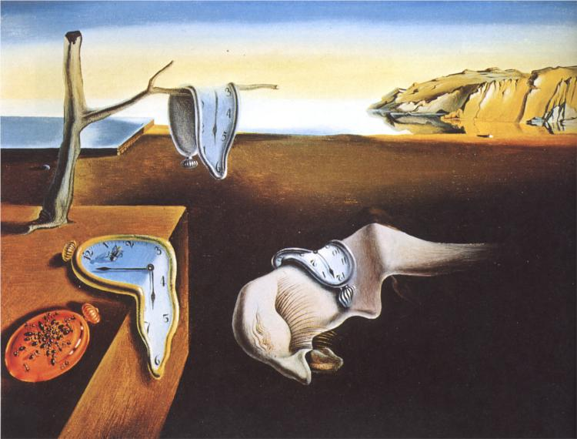

**Have no fear of perfection - you'll never reach it.**

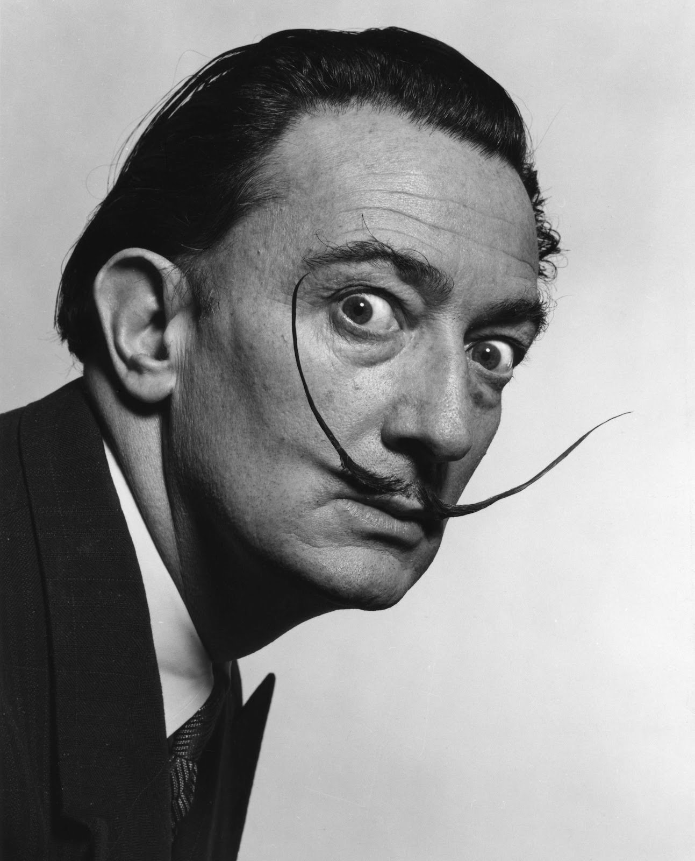

Salvador Dalí

**(Spanish Artists , May 11, 1904 – January 23, 1989)**

Mistakes are almost always of a sacred nature. Never try to correct them. On the contrary: rationalize them,

understand them thoroughly. After that, it will be possible for you to sublimate them.　　　　S. Dali